ANSIBLE [Task-01]

**1) Watch ansible-01 video and write down notes.**

**2) Setup one master and two worker nodes in ansible.**

Launched the 3 Instances with Ubuntu AMI

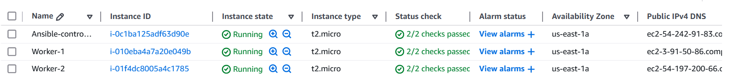

Now, go to the ansible-controller instance

Checking the python version[as it is prerequisite]



Now, Installing the ansible with the commands

* sudo apt install -y software-properties-common
* sudo add-apt-repository --yes --update ppa:ansible/ansible
* sudo apt install -y ansible

checking the version of the ansible

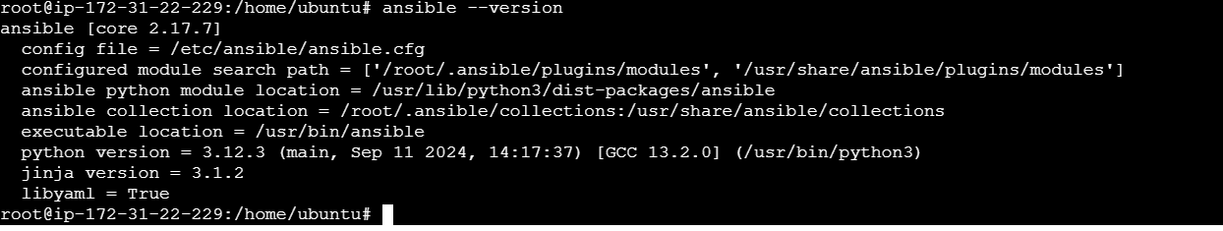

Now, go to the /etc/ansible directory

In that edit the hosts file with the slave - ips

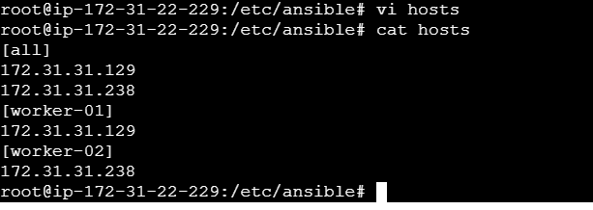

Now Creating Passwordless authentication for the worker[Nodes]

2) create a ssh keygen

ssh-keygen -t rsa

3)copy public key

cat id_rsa.pub

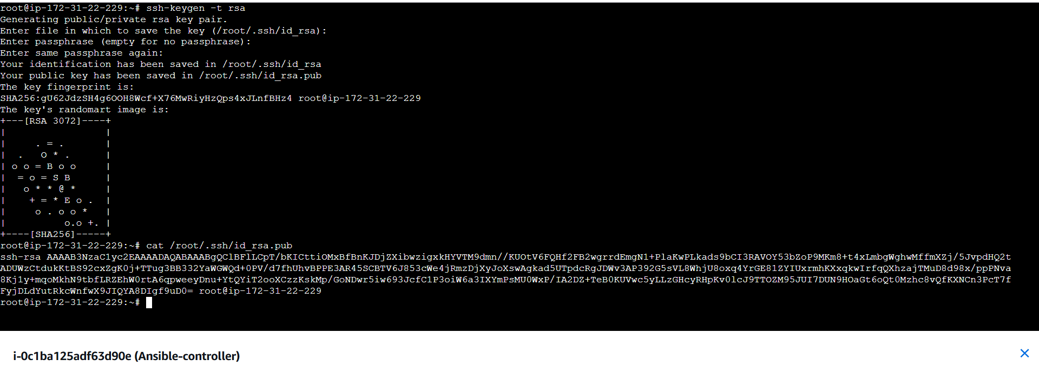

3)paste the ssh- key in the slave machines

On slave-01 machine

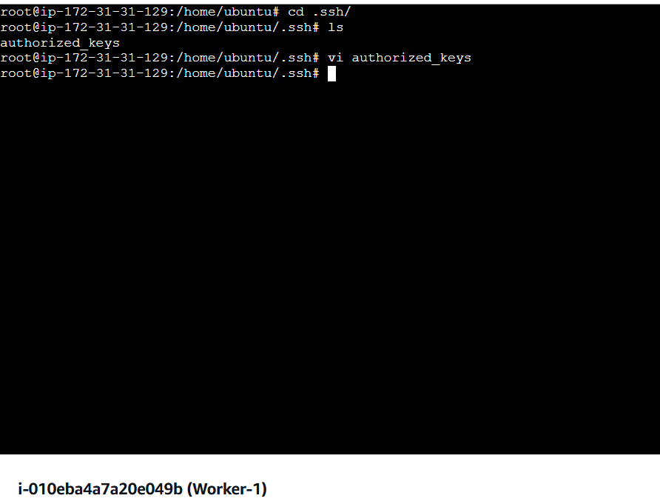

On Slave-02,also configured the same

Now we can check the connectivity of the two slaves

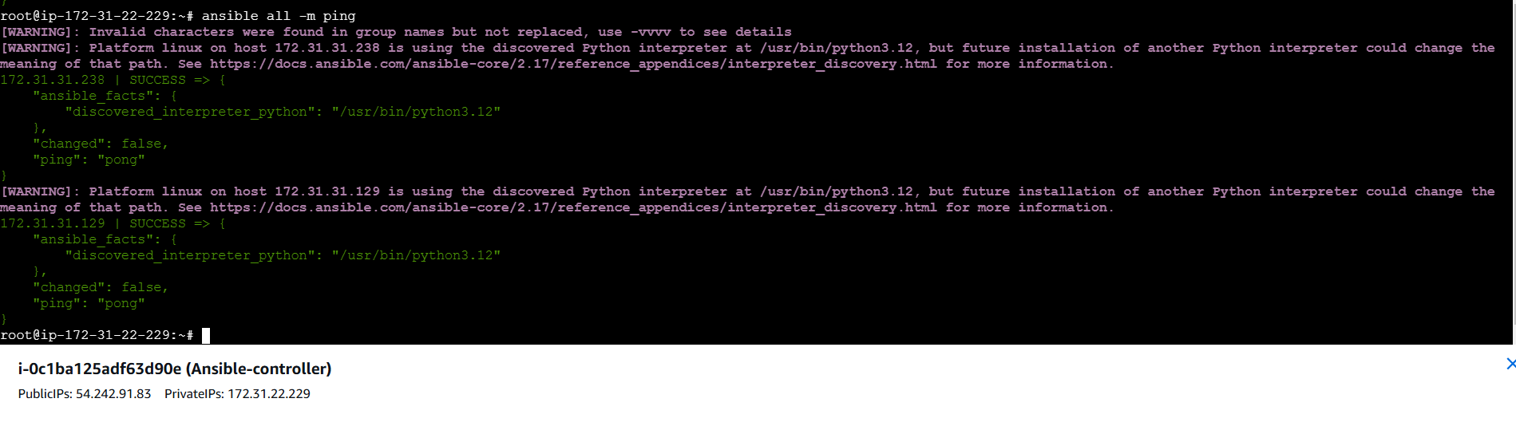

We can also check individual connection of the workers

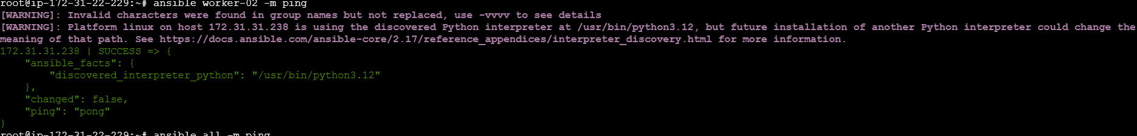

**3) Execute the adhoc command**

***To check the connetivity between slaves***

ansible all -m ping



***How to gather facts of slave machine***

ansible all -m setup



***TO check the uptime of a slave machine***

ansible all -a uptime

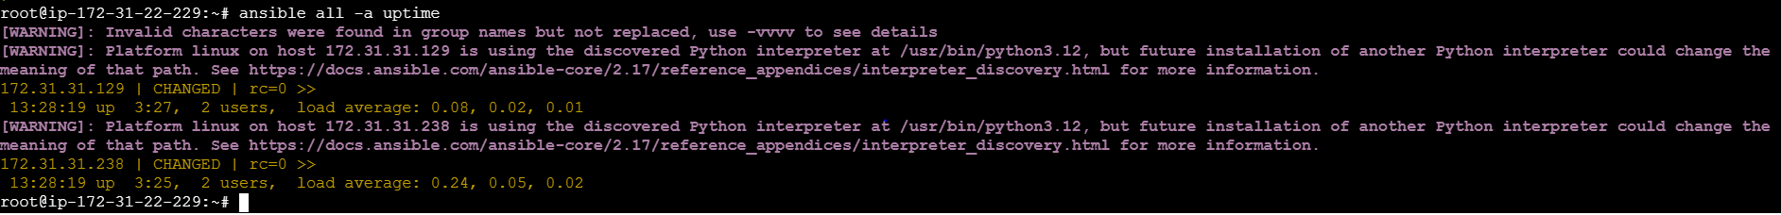

***check the free memory or memory usage of host***

ansible all -a "free -m"

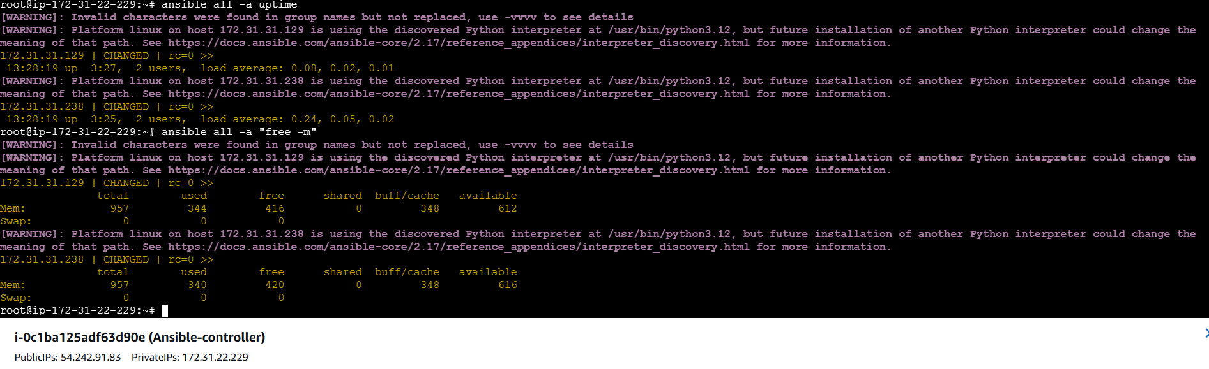

***Change ownership of a file***

ansible all -m file -a "path=/root/sample group=ubuntu owner=ubuntu" –b

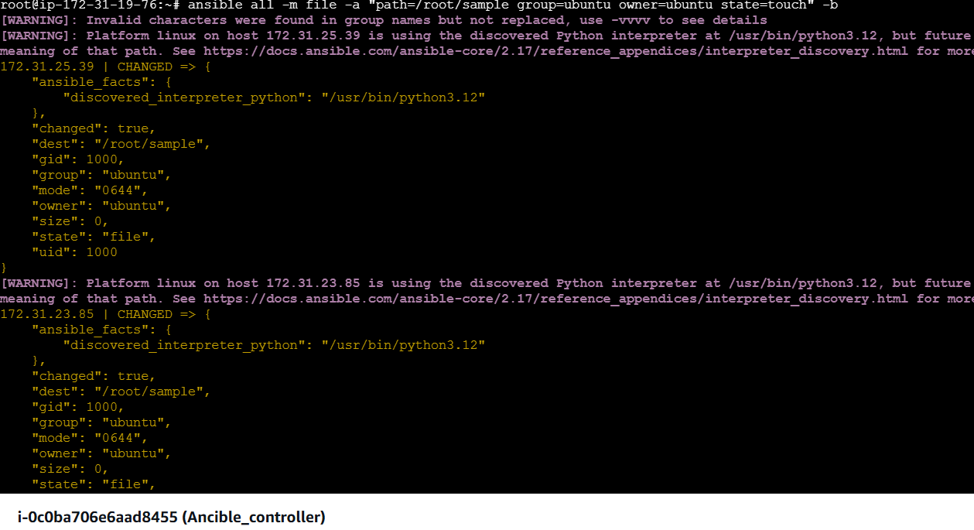

We can check on both the workers machine,the permisions of the file”sample” changed .

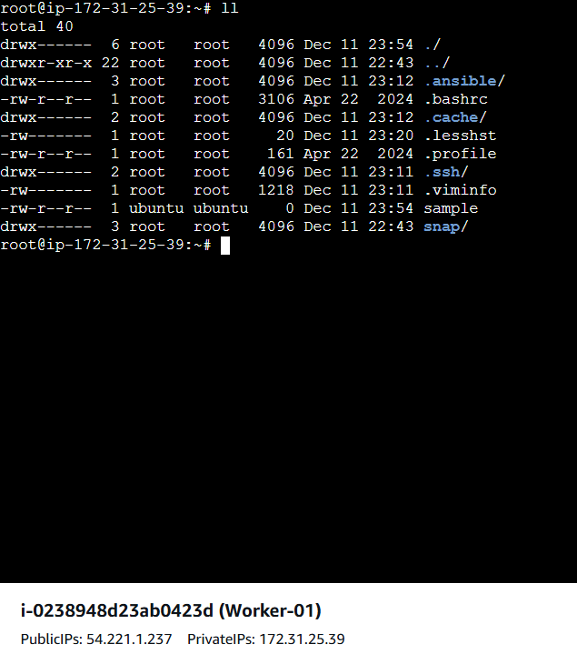

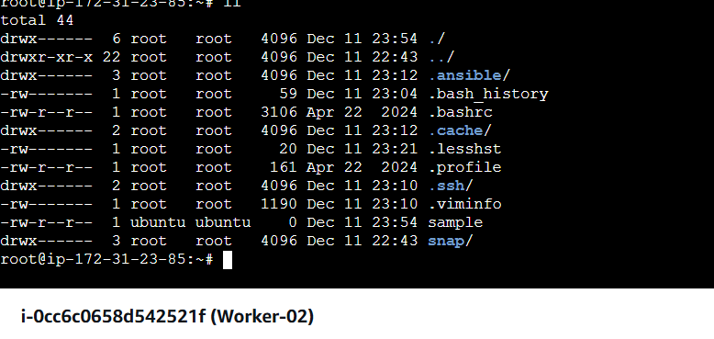

# ***Create a file with 755 permission***

ansible all -m file -a "path=/home/asnadm/testfile state=touch mode=0755"

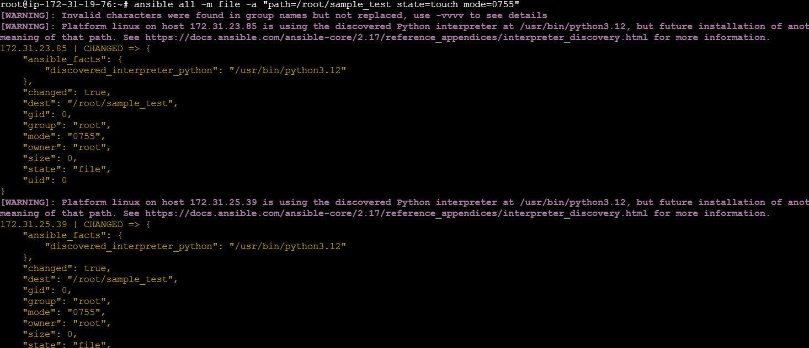

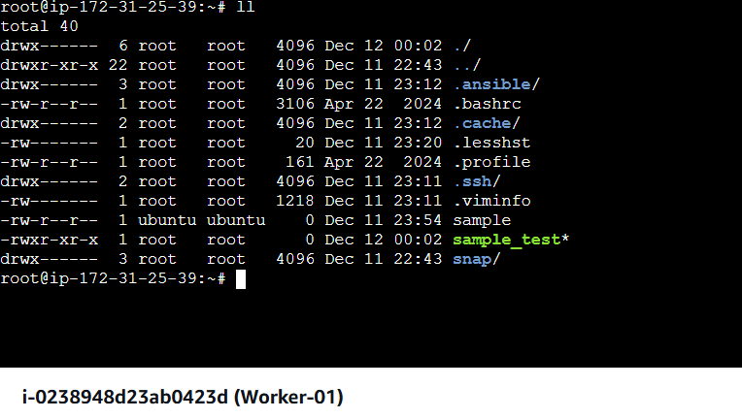

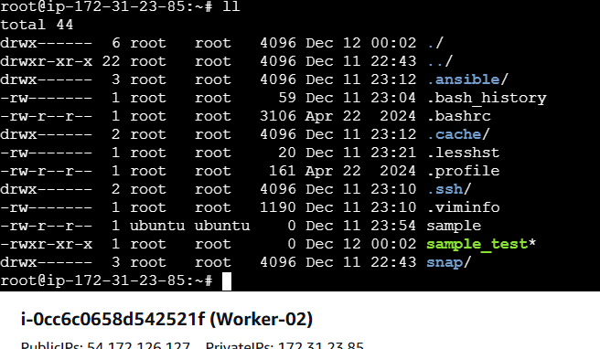

***Install a package using apt command***

ansible all -m apt -a "name=apache2 state=latest"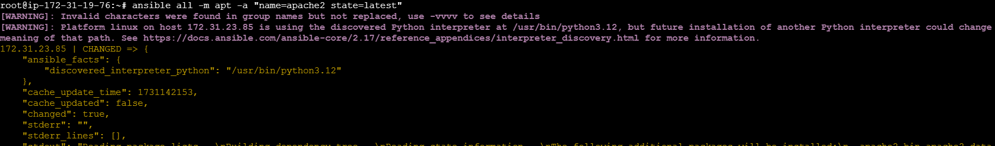

***Start or stop the service***

***# To Start***

ansible all -m service -a "name=apache2 state=started enabled=yes"

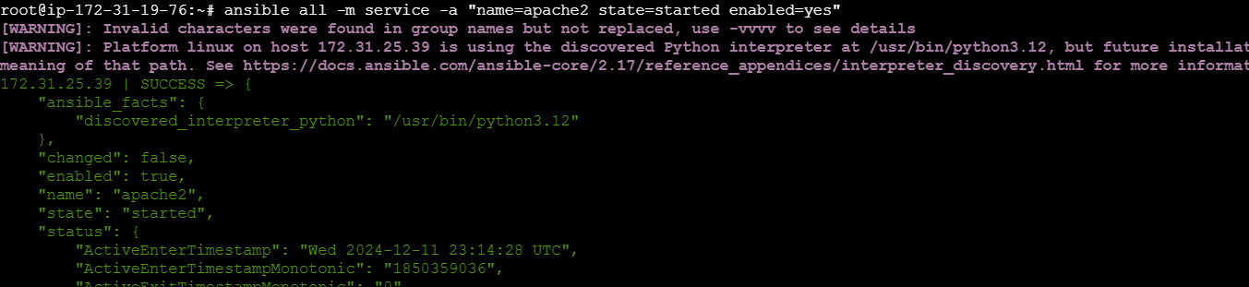

On Worker-01

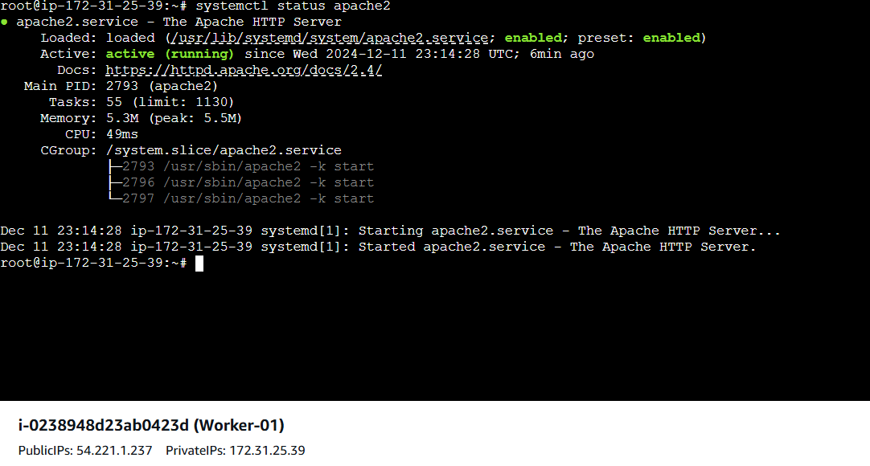

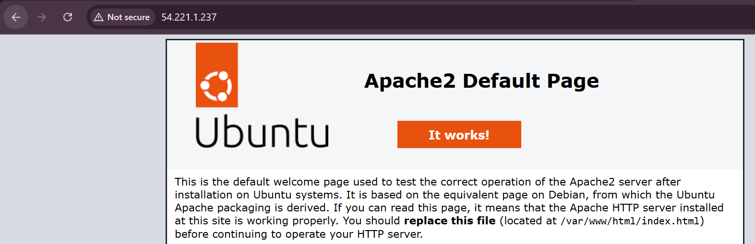

On Worker-02

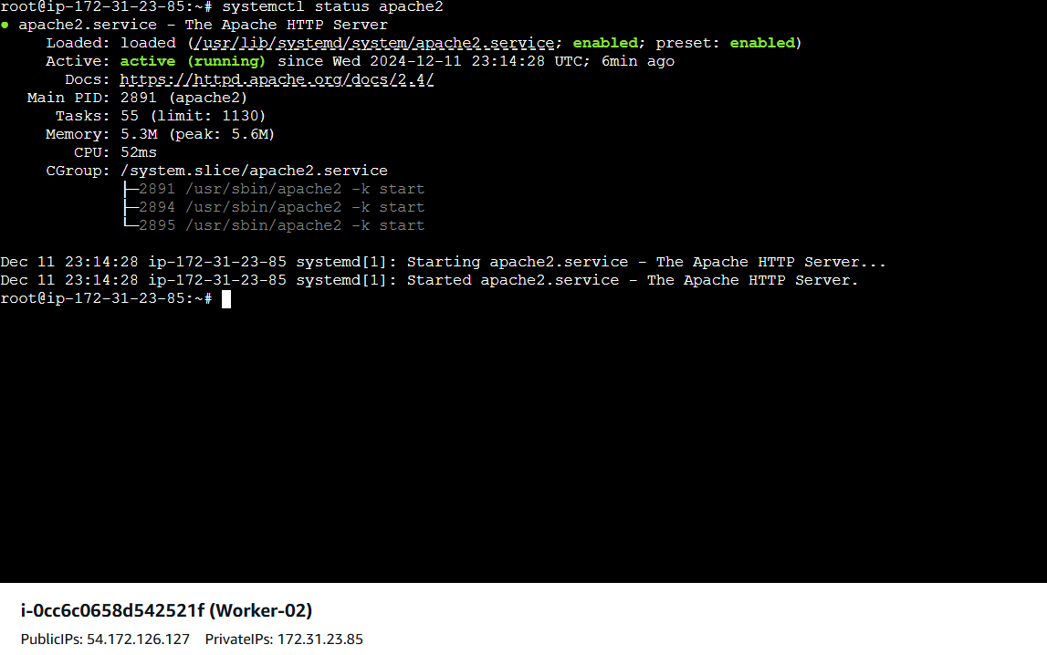

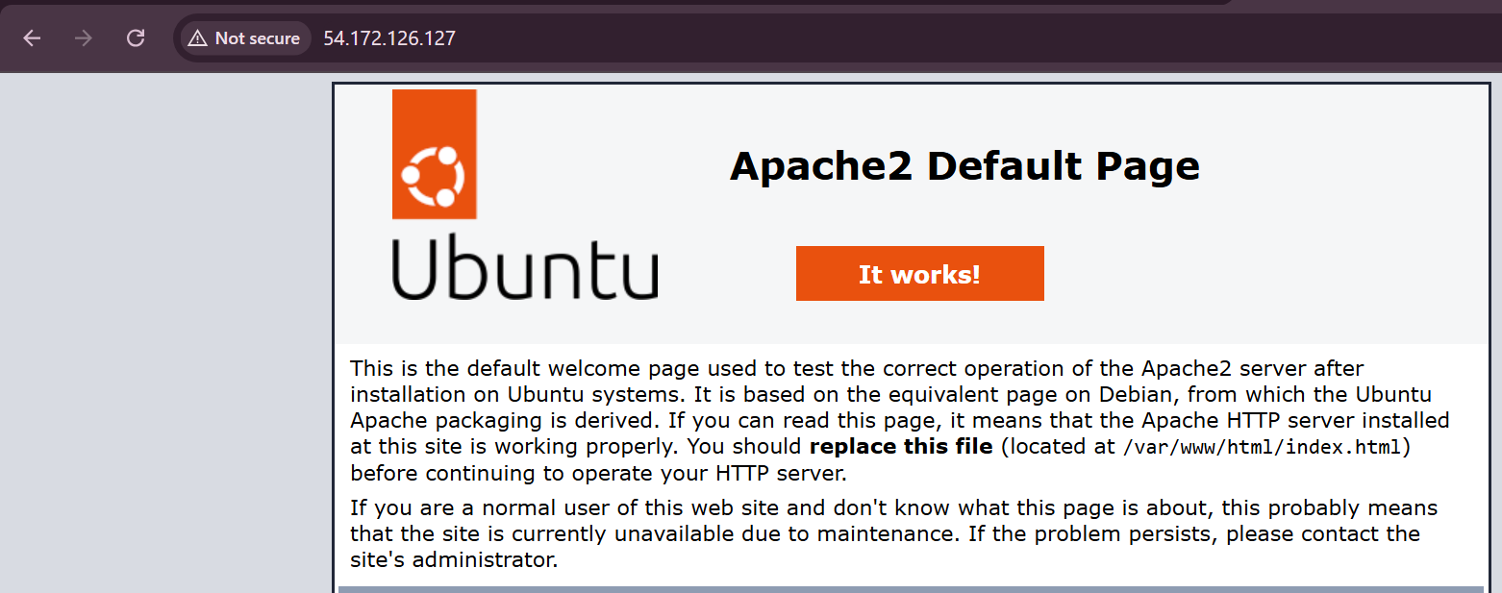

***# To Stop***

ansible all -m service -a "name=apache2 state=stopped enabled=yes"

